Once upon a time, there were three bears who lived in a little house in the woods.

T hey were -
Daddy Bear
Mummy Bear
and
Baby Bear.
One day, Mummy Bear made some porridge for breakfast.

It was too hot to eat, so the bears went for a walk while the porridge cooled.
While they were out, a little girl called Goldilocks came past their house.

She stopped. She looked.

Then she walked inside!
On the table were three bowls of porridge.

She wanted to eat them.

The big one was too salty.
The medium one was too sweet.
The small bowl was just right.

So she ate it all up!
Then Goldilocks saw three chairs.

She wanted to sit on them.

The first chair was too high.
The second chair was too low.
The third chair was just right.

She rocked too hard and broke it!
Goldilocks went upstairs.

There were three beds.

The large one was too hard.
The middle sized one was too soft.
The little one was just right.

Goldilocks fell fast asleep.
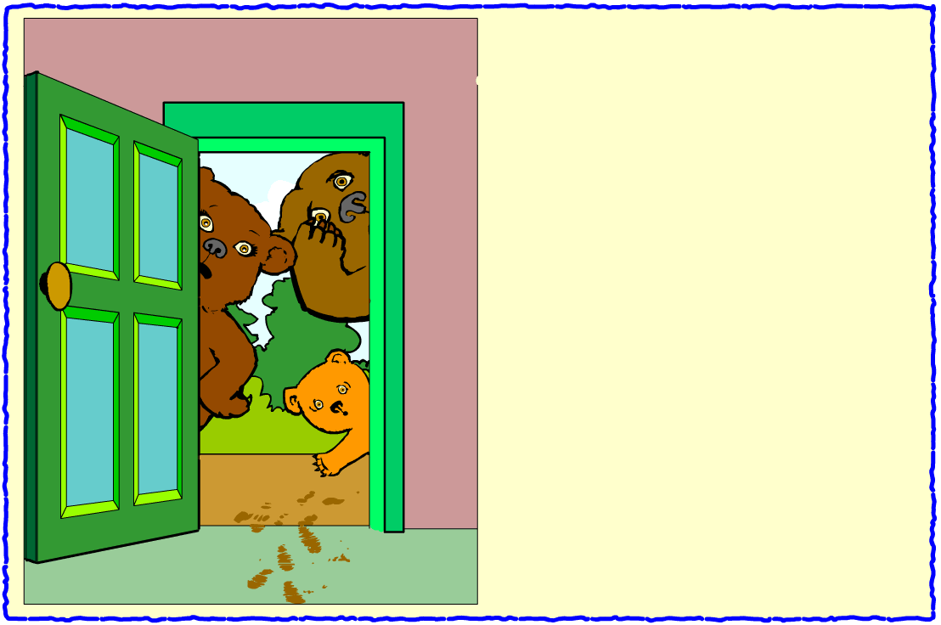
The three bears came home.

They could see someone had come into their house.

"Someone's been eating my porridge," grumbled Daddy Bear.

"Someone's been eating my porridge," grumbled Mummy Bear.

"Someone's been eating MY porridge," cried Baby Bear. "And they've eaten it all up!"
"Someone's been eating my porridge," grumbled Daddy Bear.

"Someone's been eating my porridge," grumbled Mummy Bear.

"Someone's been eating MY porridge," grumbled Baby Bear. "And they've eaten it all up!"
They went into the living room.

"Someone's been sitting in my chair,"
growled Daddy Bear.

"Someone's been sitting in my chair,"
growled Mummy Bear.

"Someone's been sitting in my chair," growled Baby Bear. "And they've broken it!"

Goldilocks woke up. She saw the three angry bears.

She was scared.

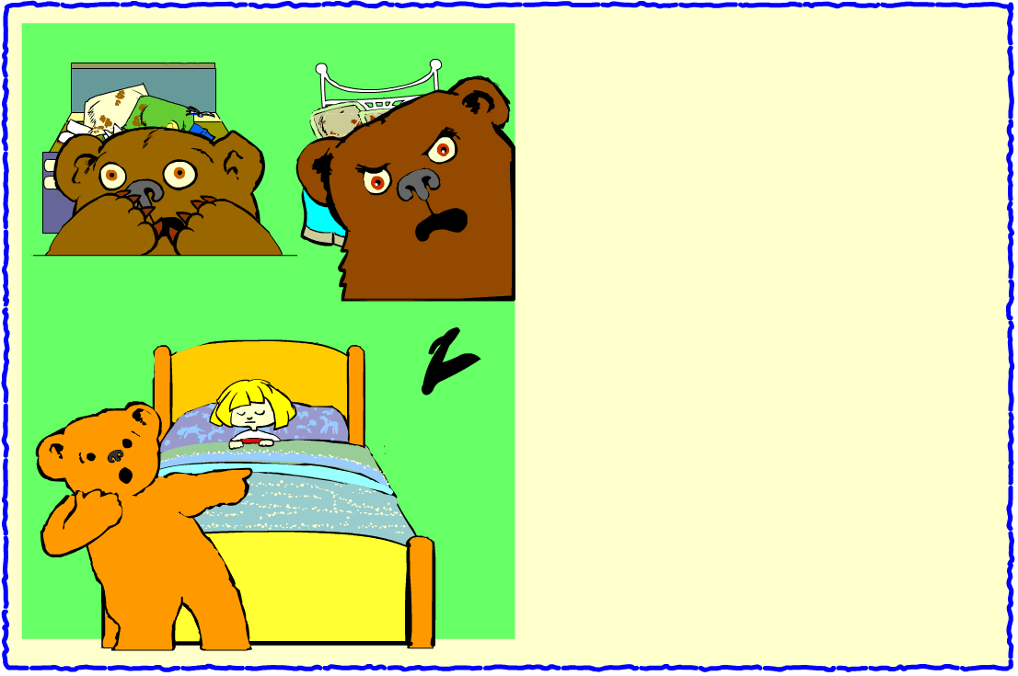
They went upstairs.

"Someone's been sleeping in my bed," roared Daddy Bear.

"Someone's been sleeping in my bed,"
roared Mummy Bear.

"Someone's been sleeping in my bed,"
roared Baby Bear.
"And she's still there!"

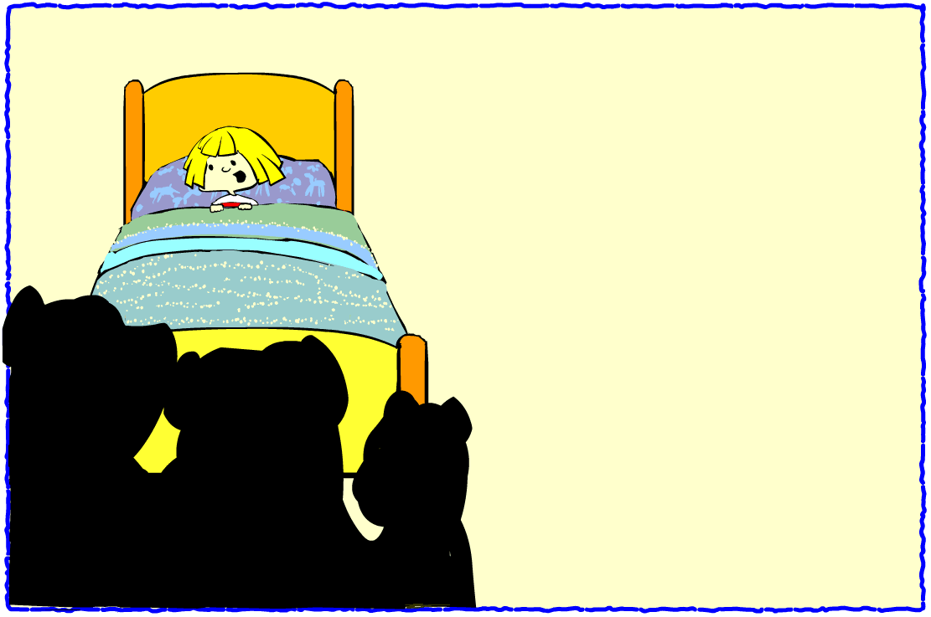
Goldilocks woke up. She saw the three angry bears.

She was scared.

So she jumped up, ran out the door, and did not stop until she was home.

Goldilocks never went back to the bears' house again.

But she did send them a letter to say she was sorry.

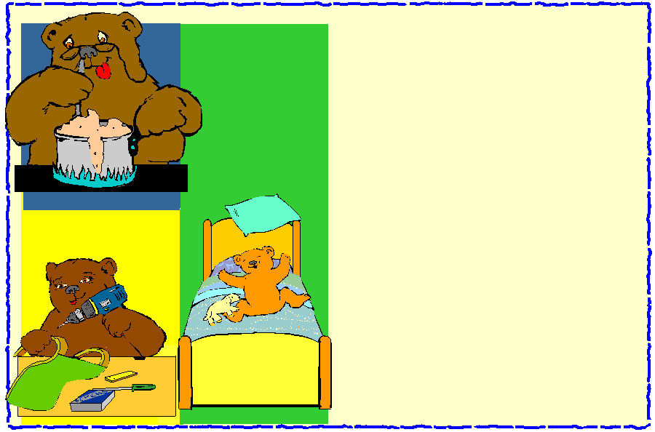

Daddy Bear made more porridge.

Mummy Bear fixed the broken chair.

And Baby Bear made the beds!

